Introduction to EDR - Lab Report

Date: 16/08/2026
Difficulty: Easy
Category: Core SOC Solutions
Platform: TryHackMe

Overview

This lab focuses on what an Endpoint Detection and Response (EDR) is and how the three pillars – visibility, detection and response are used to effectively keep endpoints secure. There is also a practical which gives hands on experience of using an EDR solution to investigate alerts.

2. What I did

To ensure that endpoint devices are protected, Endpoint Detection and Response (EDR) solutions are used to secure devices and fight advanced threats no matter where the endpoints are. Some commonly used EDR solutions include CrowdStrike Falcon, Microsoft Defender for Endpoint and SentinelOne ActiveEDR. There are 3 pillars of an EDR solution – Visibility, Detection and Response.

- Visibility – It collects data from endpoints such as process modifications, registry modifications, file and folder modifications, user actions and much more. It structures this data in a process tree for the analyst to easily review and come back to for threat hunting.
- Detection – It uses signatured-based detections and behaviour-based detections like unexpected user actions. It makes use of machine learning to find any unusual activity from the baseline behaviour and alerts analysts to its findings. A dashboard is used to show all the detections and has a row which includes details such as severity, time, hostname and much more. The tactic via technique field maps the detection with MITRE.
- Response – It allows analysts to act on the detected threats such as isolating the endpoint, terminating a process or quarantining files from within the EDR console. Analysts can also remotely access the shell of any endpoint to gain deeper visibility into the system or take actions within the endpoints.

EDR and Antivirus are both used to protect endpoints as a defence in depth approach as attackers will find it harder to get past both solutions rather than if just one was used or configured. EDR agents (sensors) can be deployed inside endpoints as the eyes and ears of the EDR. Their main job is to sit at the endpoint and monitor traffic to send to the EDR console. The EDR console takes all the traffic from the agents and is matched with threat intelligence which can trigger alerts. Once an alert is triggered, it is the analyst’s job to sort the alert based on severity and then determine if it is a false or true positive and take actions within the EDR console. It is important to note that EDR’s are used alongside other security solutions such as firewalls, DLP’s, email security gateways and more which are all typically integrated into a SIEM which becomes the central point of investigation for SOC analysts.

Telemetry is the data which is collected by the agents from different endpoints. The larger amount of data that is collected, the easier it is to make decisions. It collects data such as process executions and terminations, network connections, command line activity, file and folders modifications and registry modifications.

Practical

The practical for this lab is about handling alerts on an EDR console.

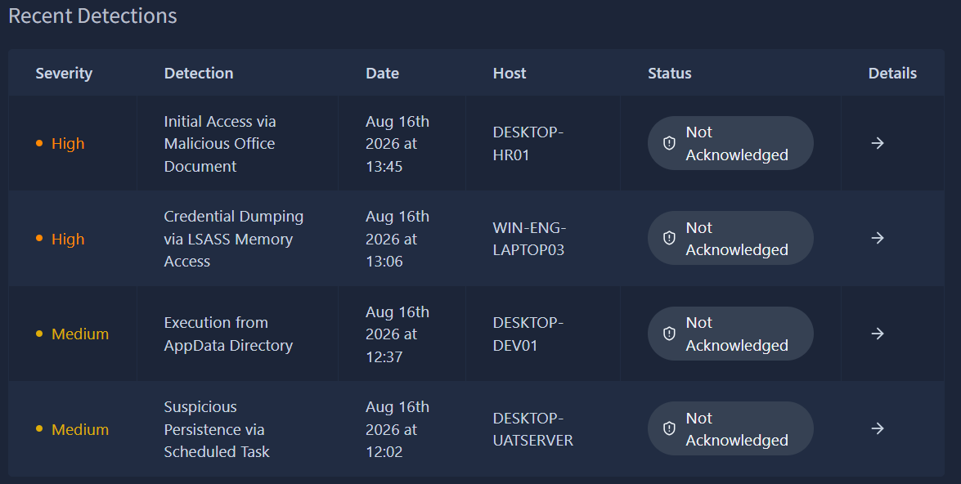

On the first detection, the Curl.exe tool was launched by CMD.exe to download the malicious payload on the DESKTOP-HR01 endpoint.

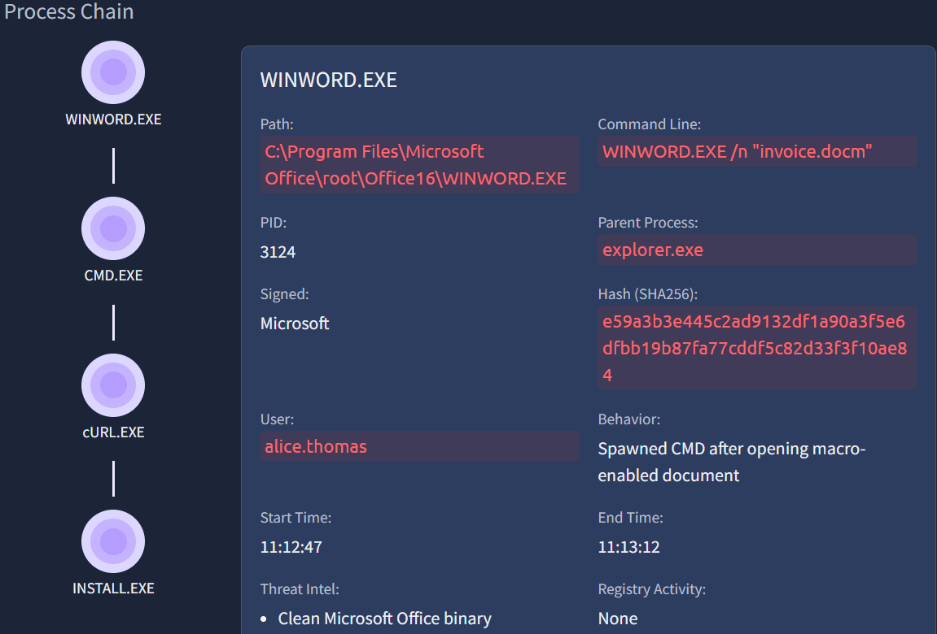

The IoCs page shows the filename, domain, IP address, hash and file paths.

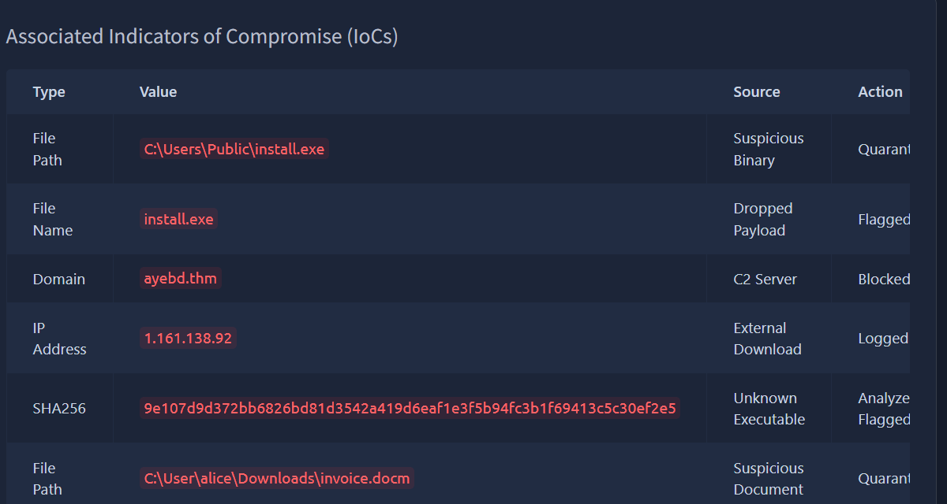

3. What I’ve learned

- What an EDR is
- The 3 pillars of EDR
- Hands on experience of investigating alerts using an EDR

